**Yasmeen Lamaa**

**202202478**

**EECE 435 L – Lab 5**

**Snapshots**

**Add User 1:**

**Add User 2:**

**Get User ID 1:**

**Get Users:**

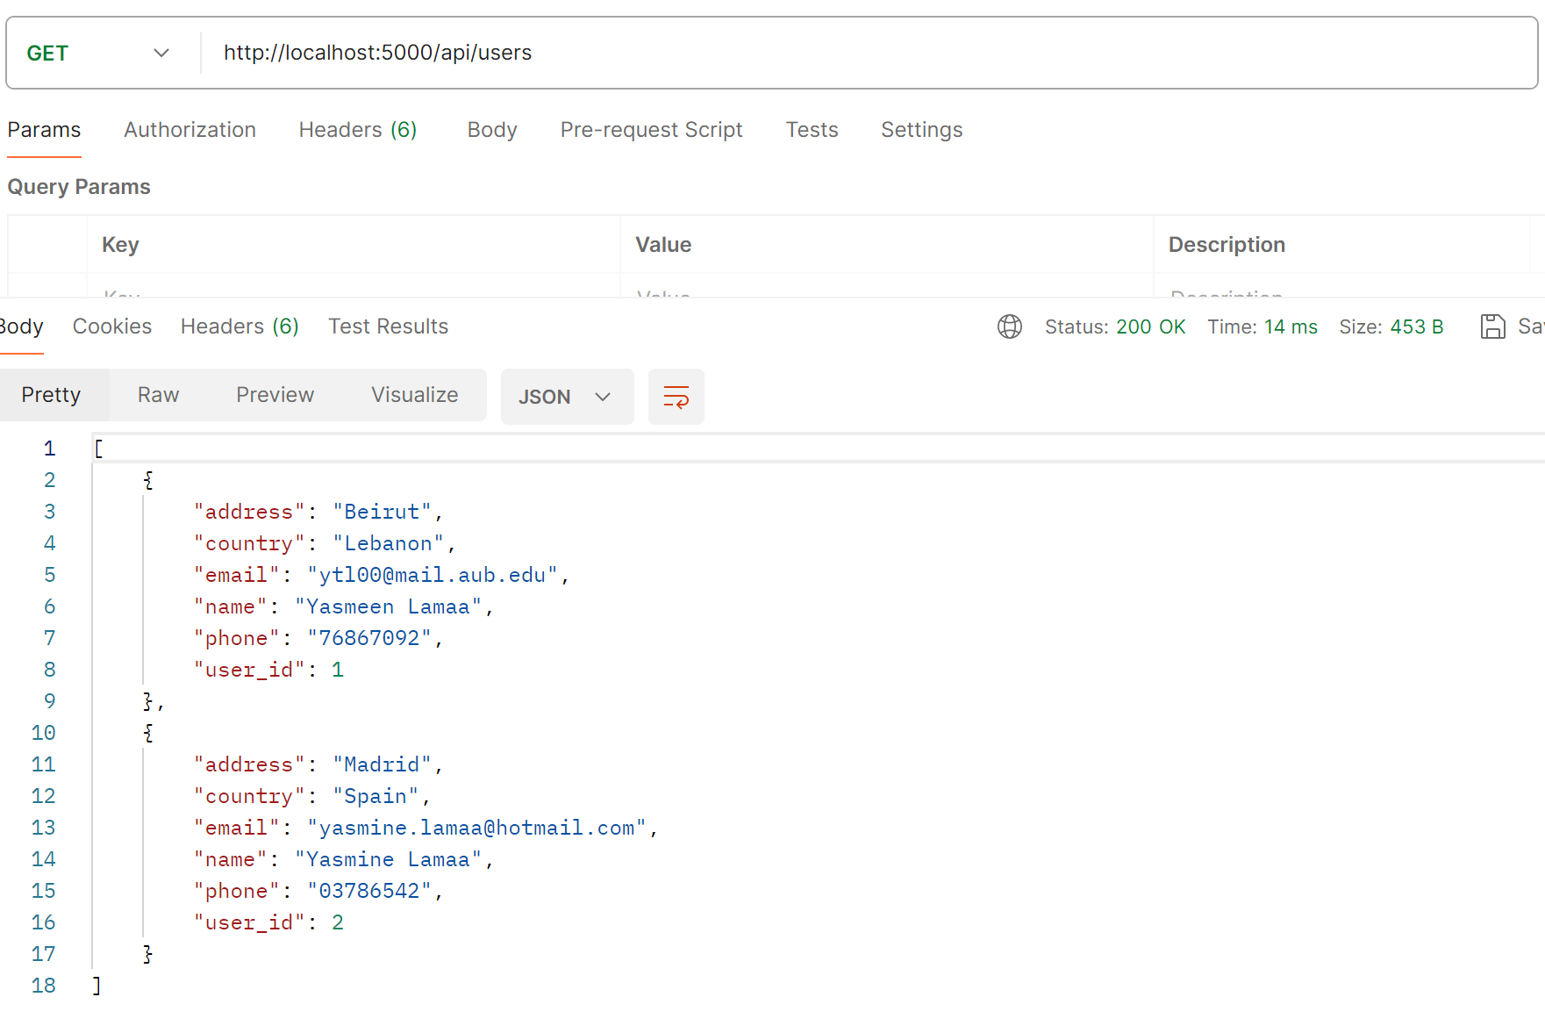

**Update User 2 - Location:**

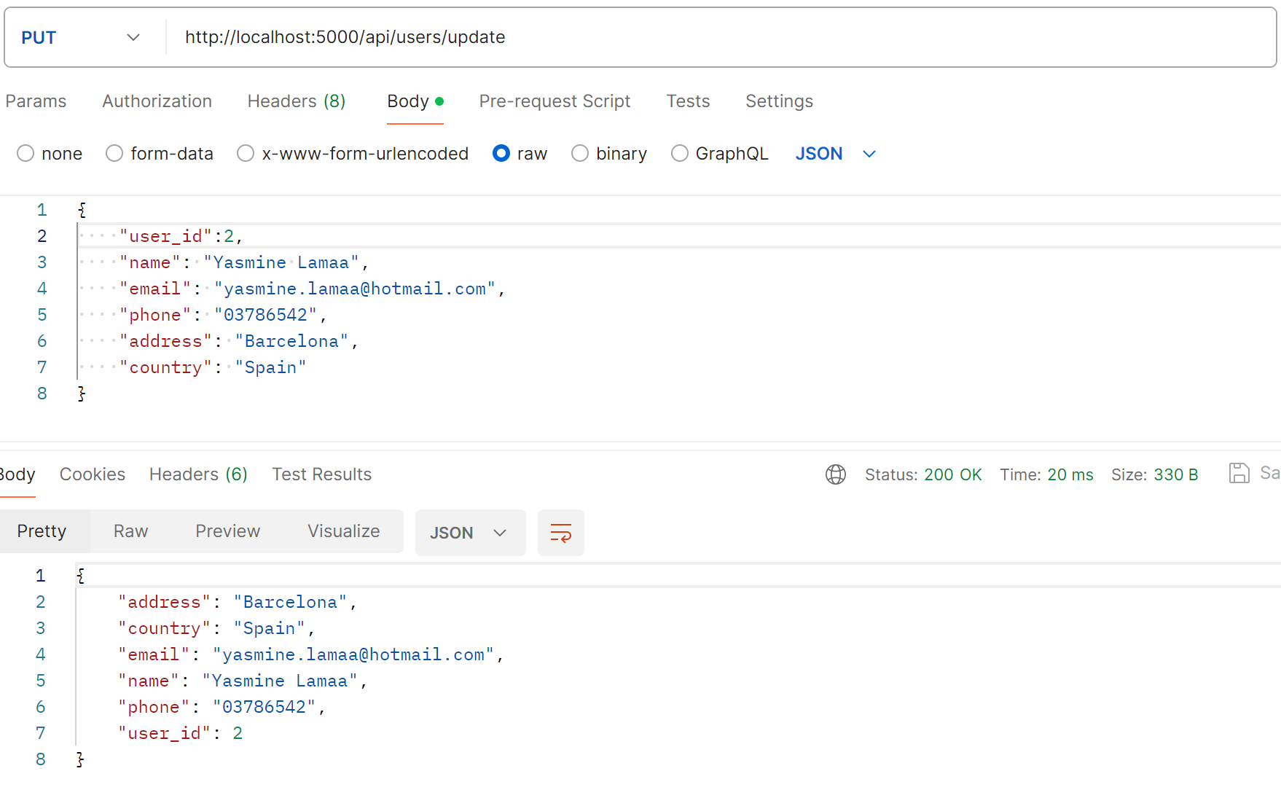

**Get User ID 2- Updated Location:**

**Delete User 2:**

**Get Users- we notice User 2 got deleted:**

